**Python Intro**

In the python code, you have many modules to choose from and classes to choose from. To start off, import the needed modules. In the favorite.py code, we imported the following.

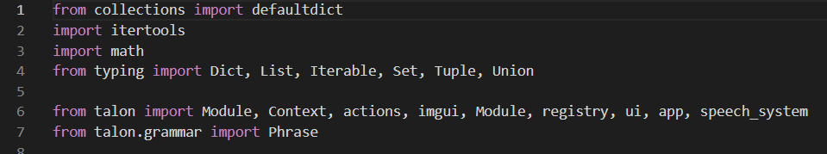

From there, we can define functions. In order to have a function defined that can be executed from a .Talon command, we must define the functions in the class Actions. In order to do that, we follow the image below.

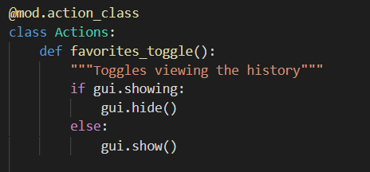

First we @mod.action_class and then create the class Actions: below. These actions are shared between files in the user folder as well so you can reuse the functions in future code

When defining a function for the class Actions: you must include a label for the function. We do this by following the red line above “”” label”””.

In order to call on these functions in a .talon file you simply define the command user.command_name() where command_name is the name of your defined function in the python code. You see this in the favorite.talon file

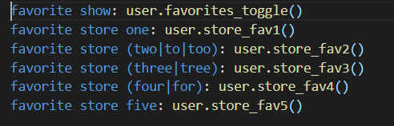

Further examples of python code is found in the user/code folder in knausj

The .talon files are found in various places, the most useful location I’ve found them in is user/misc in knausj